**Chapter 3: The mathematics of climate change.**

1. **Introduction**

Without question, climate change, and its effects on the environment and on society, is one of the most important, and controversial, issues facing all of us at the current time. It raises high passions on all sides of the media and of the political spectrum. Whilst the vast majority of scientists believe that there is good evidence for human influenced climate change, there is by no means 100% agreement as to either its importance or of the impact in the future. Hugely important questions remain such as. Is climate change happening? If it is happening is it due to human or natural causes? Will the effect of climate change be positive or negative? If there are negative effects and they are due to human causes, can anything be done about them, or are we past the point of no return?

In this Chapter we will be concentrating on the mathematical aspects of these questions using both the ideas of mathematical modelling described in Chapter 1 and the dynamical systems and chaos theory we met in Chapter 2. We will combine these with the other areas of probability, statistics, and scientific computing, to clarify our current understanding of the climate. Using these we can make predictions for the future climate, and can qualify these predictions by clear measures of their uncertainty. An important reason for doing this, is that many of the current predictions, which are used by bodies such as the Intergovernmental Panel for Climate Change (the IPCC), are based on huge computer models. Indeed the IPCC reports, for example [1], are based on these predictions. It is these models which have also led to the 2016 Paris Agreement [2], that we should restrict our CO2 emissions in such a way to keep the Earth’s temperature rise to below 1.5 degrees Centigrade. These complex models are, in turn, based on mathematical formulations of the physics governing the climate, informed by statistical measurements of the existing climate. Thus to have an informed debate about the future of the climate of this planet, the public has a right to know how these models are constructed, how they are tested, what sort of predictions they make, and (crucially) how reliable are their predictions? In fact climate models are the most certain (or the least uncertain) of a whole set of models used to determine the effect of the climate on human beings. I illustrate these below. For this Chapter I will talk about the blue part of this figure, which also includes the variations in the amount of energy that the Earth receives from the Sun.

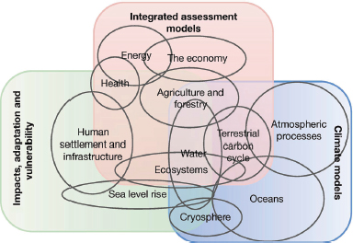

Without question weather has a huge affect on us all, and if weather patterns are changing due to climate variation then we need to take this seriously. I cannot resist telling you a story from my own experience. A few years ago I organised a seminar at my home institution of the University of Bath. The seminar was to have been given by an expert from the Met Office and her subject was ‘The effect of extreme weather on the transport network’. On the morning of the seminar she rang me up. Owing to the effect of severe weather on the transport network the trains between Exeter and Bath were not running, so she could not make it in! How I enjoyed sending the email explaining why the seminar was cancelled (and the wonderful responses that I received), it made the point better than actually giving the seminar itself. (I should say that later in the year we did have the seminar, and it was excellent).

I will start this chapter by looking at evidence for climate change, both in the past and in the present. I will then describe the way that mathematical climate models work and show how these can make predictions with quantifiable uncertainty. Then I will finish by asking the mathematical question of whether the climate has reached one of the tipping points that we looked at in Chapter 2. Anyone interested in the broader issues of environmental change, its implications on society, and the changes that we need to make in view of it, can find a very readable account of the issues related to climate change is given in the Ladybird book [3].

1. **What is the evidence for climate change?**
   1. **Current changes in the climate**

There is a lot of statistical evidence that the current climate is changing, even if the reasons for this change and the significance of it, are the subject of hot debate. This evidence can, in turn, be used as a test of our climate change models. I will now look at four examples of this taken from the physical world, which can be measured directly and also checked in the climate models I will describe later.

*A. Global Warming*

According to the IPCC *5th Assessment Report WG1 -­ Science Basis “Warming of the climate system is unequivocal, and since the 1950s, many of the observed changes are unprecedented over decades to millennia.”* [4]

So, let’s look at the actual evidence for this. Recent records on the Earth’s temperature come from a variety of different sources including weather stations on the Earth’s surface, satellites orbiting the Earth, and buoys and ships in the ocean. In the case of the weather stations, these records have been gathered reliably since the foundation of the Met Office in 1850. A graph of these is given below up to 2017, in which we show the Earth’s average temperature each year, compared to the 1951-1980 average temperature.

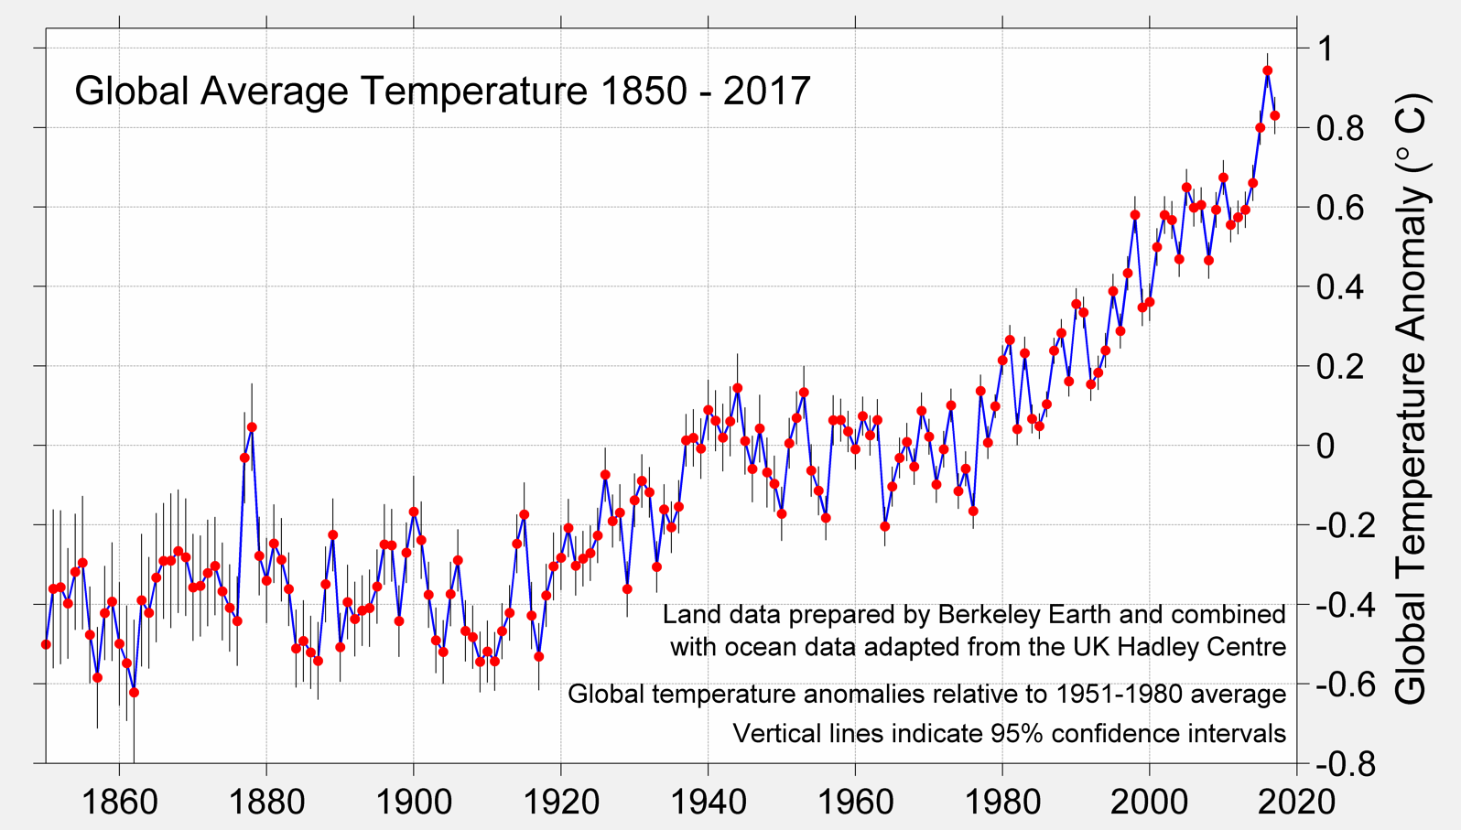

In this period the average temperature of the Earth has gone up and down from year to year, due to such factors as the El Nino (a warming of the Southern Pacific ocean due to the effect of ocean currents), other ocean current related effects, and also large volcanic eruptions such as Krakatoa in 1883. However these variations are superimposed on a trend, which is clearly rising. Indeed in 2015 the Earth was on average 1 degree Centigrade warmer than it was when these records began, and the last three decades have been the warmest ever recorded

*B. Loss of ice and sea level rise*

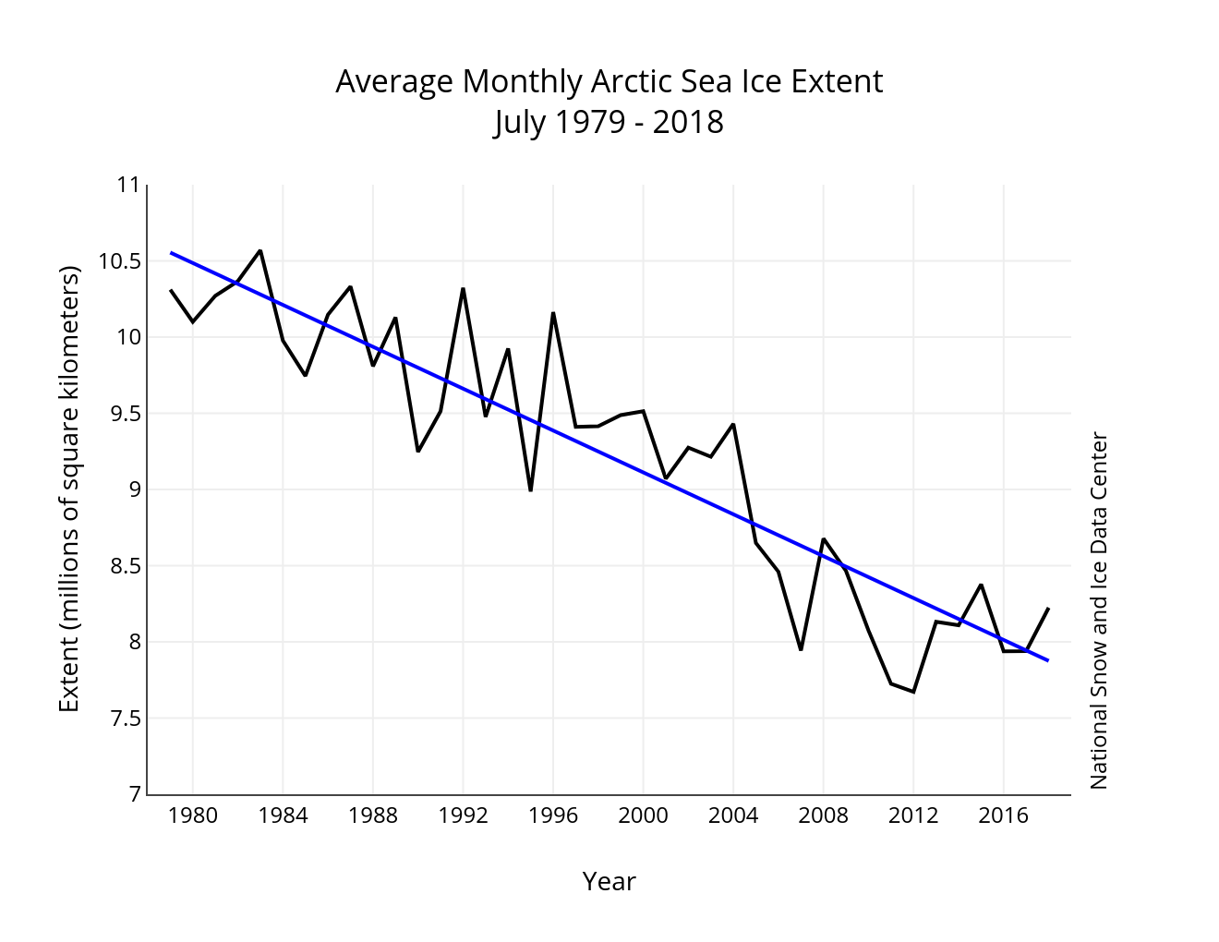A direct consequence of global warming, and one of the clearest indications of its impact, has been the loss of the Arctic Sea Ice. Clear evidence of this is available from the NASA National Snow and Ice Data Center satellite, which has monitored the extent of the summer sea ice since 1979. The resulting graph, below shows a very clear trend downwards (indicated by the blue line)

In 36 years approximately 2.5 million square kilometres of summer sea ice have been lost. This is equivalent to the area of Scotland every year. If this rate of loss continues, all of the Arctic sea ice will have vanished in 100 years. At the same time land ice has been lost from both Antarctica and the ice sheets on Greenland

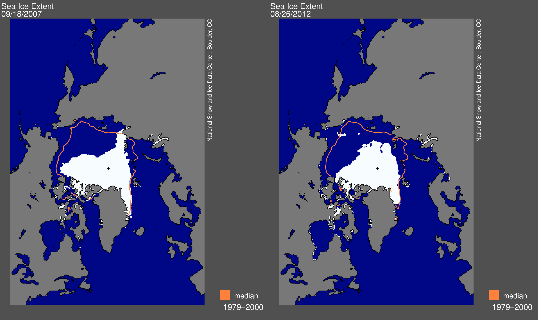

There are a number of consequences of this. The one we most hear about is the loss of habitat for such animals as the polar bears. A second consequence is a change in the salinity of the Atlantic Ocean due to the addition of the fresh water from the melting ice. This could, in the long term, have a direct influence on the ocean circulation patterns, including a shift in the direction of the North Atlantic Drift, which keeps the UK warm. (So ironically global warming at the North Pole could possibly make the UK colder.) A third long term consequence is that the Earth gets darker. One of the functions of the ice sheets is that they reflect a large amount of the Sun’s energy and keep us cooler as a result. Thus, as the ice sheets retreat so we will warm up. I will return to this topic later when we look at tipping points.

A more immediate, and observable consequence, of the melting ice, and also one, which will have significant impact on humanity, is the rise in the average sea level. There are two reasons for this. Firstly the melting of the land (but not the sea) ice adds to the volume of the water in the oceans. Secondly, as the ocean temperature increases due to global warming (as described above), so its volume increases due to the effects of thermal expansion. The increase in sea level can be measured using tide gauges and more recently by radar from orbiting satellites. This is shown below.

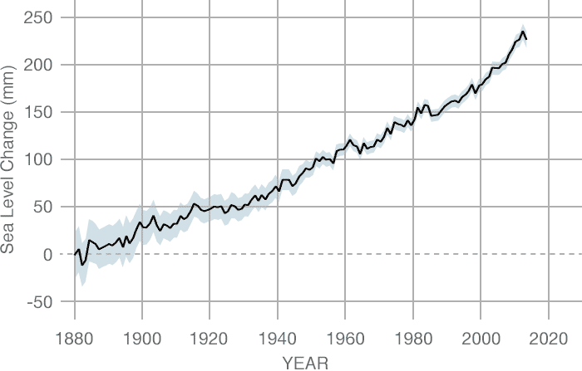

The main worry about sea level rise is the impact that it will have on low lying coastal areas, especially when compounded with storm surges and other effects of events such as hurricanes. Sustained sea level rise will make many of the worlds cities and coastal regions very vulnerable.

*C. Increases in the number of extreme events*

You have probably noticed that there have been a lot of big storms recently. For example the major wind and rain storms in the UK, including the St Valentine’s Day storm in 2014. Other recent extreme events have included the 2003 heat wave, which killed thousands of people, the severe hurricanes affecting the USA since the start of the 21st Century, and extensive flooding in Pakistan. Is this evidence for climate change? The answer is almost certainly YES, but to understand why we need to understand a bit about statistics. We saw above how the average temperature of the Earth has increased by one degree Centigrade since records began. This may not seem very much, after all the daily temperature variation is much more than this. However this shift in the mean temperature significantly increases the likelihood of extreme temperatures, and related events such as higher rainfall (as a warmer atmosphere can hold more water). To see this, have a look at the graph below.

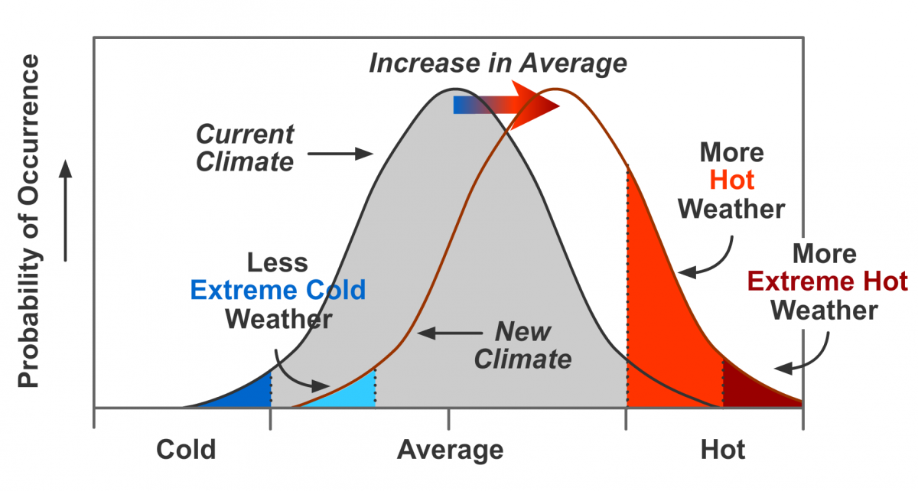

The graph on the left shows a typical statistical distribution of temperatures, which is a Bell Curve centred on the mean. The portion on the far right is the tail of the distribution and the area under the tail shows the probability of a hot temperature. The curve on the right shows what happens if the average temperature increases. This has the effect of shifting the whole bell curve to the right. The consequence on the chance of high and extreme weather is profound. The small shift to the right raises the height of the curve in the tail by a very large amount. This in turn dramatically increases the chance of having extreme weather events such as an increased frequency of tropical storms.

*D. Carbon Dioxide Increases*

It is possible to monitor the amount of Carbon Dioxide in the atmosphere with high precision. For example the Mauna Loa observatory in Hawaii takes daily measurements of the amount of Carbon Dioxide in parts per million (ppm) in the atmosphere. The disturbing results of these measurements are shown below in what is called a Keeling Curve.

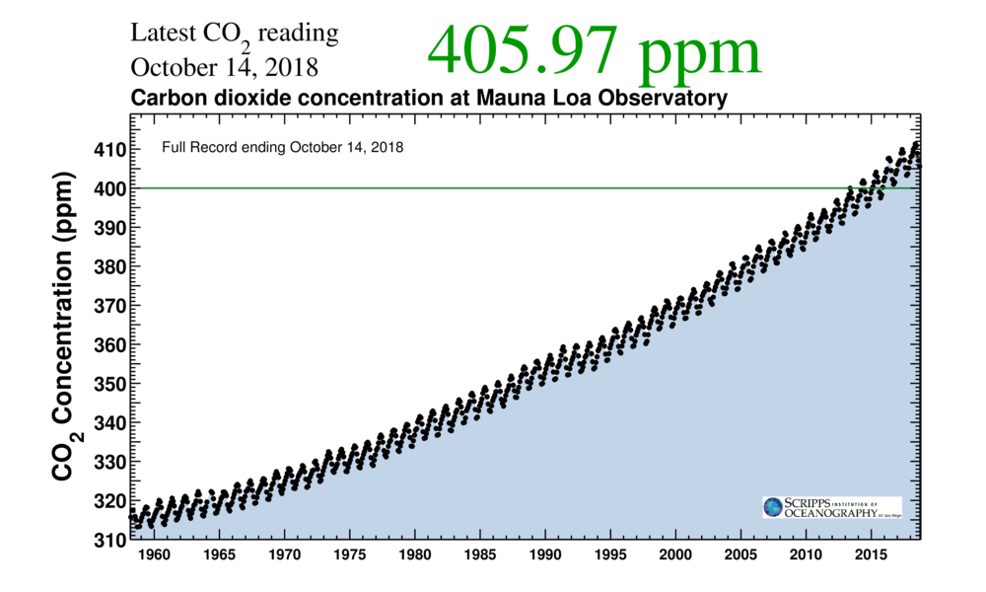

The Carbon Dioxide levels vary up and down during the course of a year owing to seasonal changes. However, the overall trend is one of rapid increase. Indeed in the last fifty years the average amount of Carbon Dioxide has risen from 320 ppm to the current value of 406 ppm. This fact is undeniable, and is almost certainly due to the burning of fossil fuels such as oil, coal and gas. However it is the impact of the Carbon Dioxide rise on the Earth’s temperature which leads to a lot of controversy and is at the heart of the IPCCs recommendations on the need for a ‘low Carbon economy’. The key question is whether the increase in Carbon Dioxide levels leads to a temperature increase (due to the ‘Greenhouse Effect’), or conversely whether it is a rise in temperature (say due to natural causes), which has led to an increase in Carbon Dioxide levels. If it is the former then we need to do something to stop a climate disaster. In the latter, we are just the victims of natural climate variations and cannot do anything about it. In practice most of the mathematical models for climate change show that temperature and Carbon Dioxide levels are closely linked with changes on one leading to changes in the other.

For example a small rise in temperature can lead to a bigger increase in Carbon Dioxide, which in turn leads to an even bigger increase in temperature. Later in this Chapter I will show how mathematical models of climate are consistent with the first viewpoint and not with the second.

A test of some of the most sophisticated climate models used by the IPCC (which will describe shortly) is to use the method of *hind-casting.* In this the climate is set to that at the beginning of the 20th Century and the models are asked to ‘predict’ the last 100 years of the Earth’s climate up to the present day. Two scenarios are typically chosen. In the first the Carbon Dioxide levels are set to the measured values which includes the effect of additional Carbon Dioxide in the atmosphere due to human activity. In the other scenario the Carbon Dioxide levels are kept at the same value that they had in 1900, allowing for natural variations due (mostly) to volcanic activity. The hind-cast tests of the climate models with the observed Carbon Dioxide levels correctly reproduce the variations in the Earth’s temperature. This helps to test and validate the models. In contrast the tests of the models with the naturally varying Carbon Dioxide levels, predicted much lower temperatures than observed. As well as testing the models, this experiment strongly demonstrates the role played by human made Carbon Dioxide in recent global warming.

**2.2 Past climate changes**

A common criticism of the above evidence for climate change is that it is simply natural and not caused by human action. To a certain extent this is correct in that there is no question at all that the climate has changed in the past, and in ways that human beings could not have been responsible for. For example about 400 years ago we were experiencing a ‘little ice age’ when temperatures were noticeably cooler than today, and then the Earth gradually warmed up. There is also clear evidence that millions, if not billions of years ago, the Earth has gone through periods of being very cold, and also of being very hot. Reasons for this include changes in the energy levels of the Sun and also the Milankovich cycles, in which wobbles of the Earth in its orbit change the amount of solar radiation (insolation) reaching the Earth’s surface. Whilst these certainly cause changes to the Earth’s climate, they are also on long timescales, such as tens of thousands of years or longer, not on the much shorter timescales of tens of years that we are currently observing.

A further criticism of the recommendations of the IPCC is that the Earth will naturally regulate its climate as it has done in the past, and that it will do so in the future. However both of these criticisms fail. In the first case, as we shall see, the observed changes in climate are the opposite of what we would expect from extrapolations of the historical. In the second case, the changes that we are currently seeing are far more rapid than any such changes in the past. It is most unclear whether the Earth’s recovery mechanisms can react fast enough to counter the effects of these. I will return to this topic later in this lecture.

Modern climate records taking direct measurements of temperature, rainfall, ice cover, and other climate indicators, really only started when the Met Office was founded in the UK. In paleo-climatology, or the study of past climates, scientists use proxy data to reconstruct past climate conditions. Proxy data are preserved physical characteristics of the environment that stand in for direct measurements. Paleo-climate scientists gather proxy data from natural recorders of climate variability such as tree rings, ice cores, bore holes, fossil pollen, ocean sediments, corals and historical data (such as the French grape harvest). By analysing records taken from these and other proxy sources, climate scientists can extend our understanding of climate well beyond the instrumental record. One of the most important of these proxy measurements is the Oxygen-18 isotope. Oxygen occurs in the Earth’s atmosphere in various isotope forms. Most of it is the Oxygen-16 isotope, but a smaller amount is the heavier Oxygen-18 isotope. The ratio between the Oxygen-16 and Oxygen-18 water molecules in an ice core, helps to determine past temperatures and snow cover. The heavier Oxygen-18 isotope condenses more readily as temperatures decrease and falls more easily as rain or snow, while the lighter Oxygen-16 isotope needs colder conditions to precipitate.

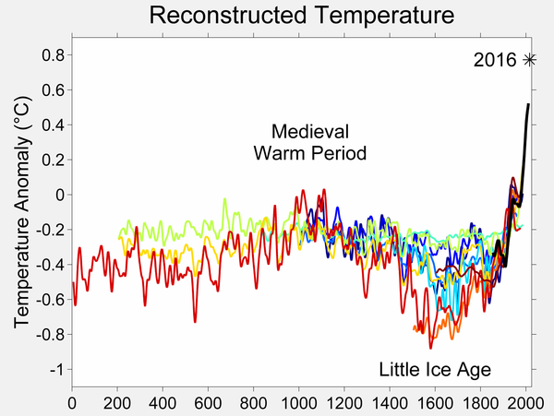

The temperature over the last 2000 years as estimated by various proxies is illustrated above

Different proxies lead to slightly different reconstructions, but the overall pattern is clear. There was a gradual warming over the first 1000 years to give the Medieval Warm period, during which Europe was warm although the rest of the Earth was rather cooler. We then see a gradual cooling resulting in the Little Ice Age which was probably to a reduction in solar activity. The little ice age is then followed by a very rapid warming as we approach the present day. By drilling deep into the Antarctic ice, and measuring the Oxygen we can find out the temperatures of the past million or so years. The results are presented below and are remarkable. In this famous figure the

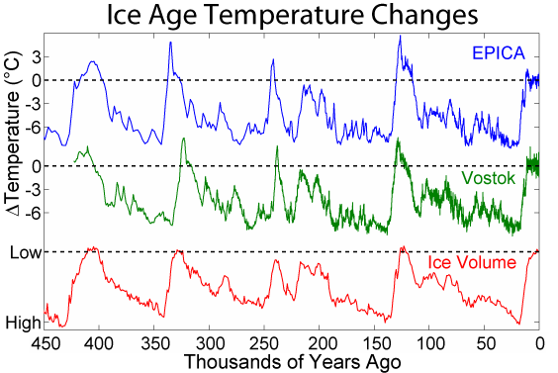

top two graphs show the temperature over the last 450 thousand years, as estimated from two different ice core samples called EPICA and Vostok. The lowest graph shows the estimated volume of the ice covering the Earth over the same time period. This figure shows clear evidence for four complete ice ages. In a typical glacial cycle the Earth gradually cools and the ice volume increases. The ice age then ends in a rapid warming period. The most recent such period was the end of the younger Dryas ice age about 10,000 years ago. This of course led to the modern age, in particular the start of agriculture and the growth of civilisation. What I find remarkable about this graph is its regular periodic behaviour. In particular we see ice ages, with large variations in temperature appearing, almost by clockwork, every 100,000 years. What is also interesting is that as we go further back in time this cycle changes and is replaced by much smaller changes in temperature every 40,000 years. We will have a look at what causes the ice ages later in this lecture. But one prediction from this regular graph is very clear. If nature was left to itself then we should be entering the cooling phase of the next ice age. Instead, things are getting warmer.

A plot of the historical values of Carbon Dioxide, given below, is equally striking. Again we can see natural cycles in the Carbon Dioxide levels between 180 ppm and 300 ppm, which are in synchrony with the temperature and ice cover variations. However as we approach the present day, and in particular since the start of the industrial revolution, the Carbon Dioxide levels have increased extremely rapidly to the current value of over 400 ppm. This man made rise is far more rapid than any natural variation.



1. **How do we model climate change?**
   1. How are climate models derived

As I said in Chapter Two it is hard to predict anything, especially in the future. Climate change is no exception to this. There are various reasons for this difficulty. The climate is very complex, it is hard to get good data (especially of the initial states), the equations for climate are hard to solve and may have multiple solutions, chaotic behaviour is always present, and it can be hard to distinguish natural effects from human intervention. A careful mathematical approach based on the ideas in Chapter One is therefore essential if we are to construct climate models with any degree of reliability, and also to be able to assess the level of uncertainty in the predictions of that model.

Climate change models are complex and large. If we link them to models of the effect of climate change on the economy and society then they get even more complex! Such models have millions, if not billions, of lines of computer code in them. So, how are the models constructed, tested and do we believe them.

As in many of the mathematical models that we considered in the last two chapters

**All climate models start from the laws of physics.**

These laws have been carefully tested and validated over centuries. Most climate models also are based on weather prediction codes, which are tested every day! Basically the climate that we see arises from the interaction of the energy coming from the sun with the atmosphere, the oceans, the ice and the vegetation.

*Weather forecasting*

The basic laws of physics for *weather forecasting* that we first met in Chapter One are the Navier-Stokes partial differential equations of fluid motion on a rotating sphere (which describe the evolution of the momentum and energy of the air and the oceans), which are coupled to the laws of Thermodynamics (which describe the evolution of the temperature, and the effect of heat on from the Sun on air, water and water vapour). Together these equations are:



(Here u is the velocity of the air and the first equation is Newton’s law balancing forces and pressures with accelerations. The second equation expresses the fact that the total amount of the air of density ρ is conserved. The third equation is one of the equations of thermo dynamics and describes how the temperature T of the air evolves. The fourth equation shows how the moisture q of the air changes. The final equation is the universal *equation of state of the atmosphere* which relates its pressure P to its density and temperature.) These equations for the weather are solved **every six hours** by the Met Office, to produce a five day weather forecast, and the predictions from these equations are tested every day. They are, however, much too complicated to solve by hand. Instead we solve them by using a computer. The first idea of doing this came from L F Richardson and his envisaged computer was a room full of students. His idea was to divide up the Earth, and its atmosphere and oceans, into a large number of small cubes.

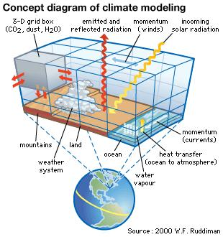

The equations of the weather are then approximated over each cube in a procedure called discretisation. For the UK forecast each such cube has a size of about 1.5 km on each side. In a typical forecast there are about a billion such discrete equations. To solve them involves inverting very large matrices and such a calculation takes about one hour on a super computer. To see more I recommend the website [5]. An image from this given below in which we see both the weather map and further information on temperature, precipitation etc.

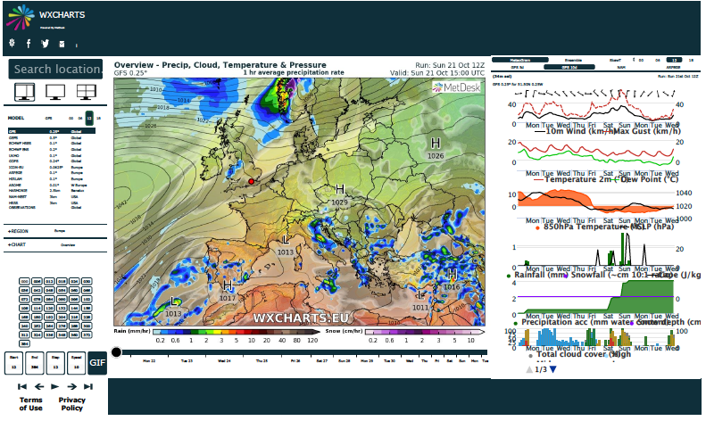

*Climate forecasting*

To see how the climate evolves we have to augment these equations. This process is hard for a number of reasons. *Firstly*, to predict climate changes we have to forecast many years ahead (sometimes thousands or millions of years). *Secondly* we have to include a lot of extra physics, chemistry and even biology. This includes ocean currents, sea ice, land ice, solar physics, complex atmospheric chemistry, vegetation (on both land and in the ocean), animals, clouds, permafrost, and greenhouse gases. *Thirdly*, the systems we are looking at in climate modelling are very nonlinear and may well have chaotic solutions, such as I described in Chapter Two. *Finally* (and most uncertainly) we have to account for the current, and future impact of humanity, including such effects as the changes amount of Carbon Dioxide in the atmosphere as the result of the burning of fossil fuels, changes in farming practices or of cutting down the rain forests. Because of the size and complexity of the resulting systems it is hard to check them, change them and to run them. It is also hard to interpret the results as they produce a mass of data (a billion data points for each forecast) which is hard to analyse and even hard to store.

* 1. What sort of models do we then use?

*Climate is what you expect, and weather is what you actually get.*

Climate models have been evolving considerably over the last decades, both in accuracy and in complexity. They evolve in parallel both with faster computers and also constantly improving mathematical models [6]. The figure below shows how the climate models have developed in complexity over the last 40 years.

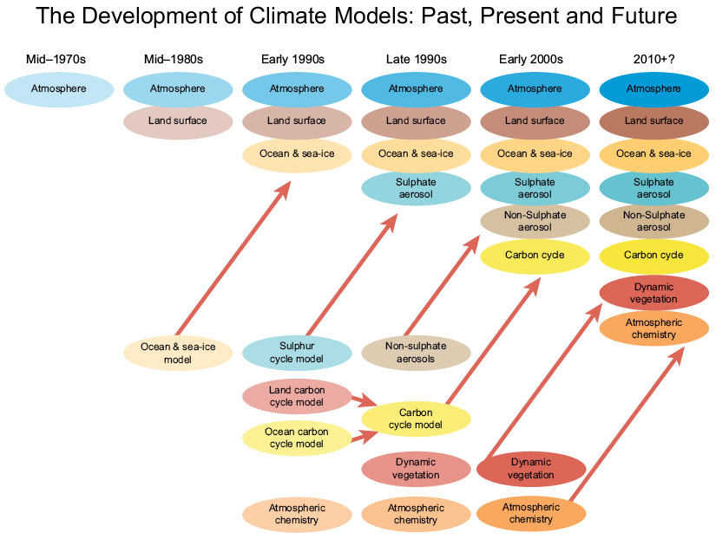

However in order to use and to run, a climate model certain approximations have to be made in comparison to a weather model. This is needed because, as we have seen climate models are much more complex than weather models. Furthermore, instead of looking five days into the future, a climate model must look decades, or even centuries, into the future. For this to be possible the spatial resolution of a climate model is much coarser than in a weather forecast. For example the cubes for the discretisation may be 100 km wide or more. Also the time steps are longer, and often the models look to find averaged quantities. There is a trade off in the amount of spatial resolution against the length of time that these models can predict into the future, and the different codes used by the Met Office and Hadley Centre are illustrated below.

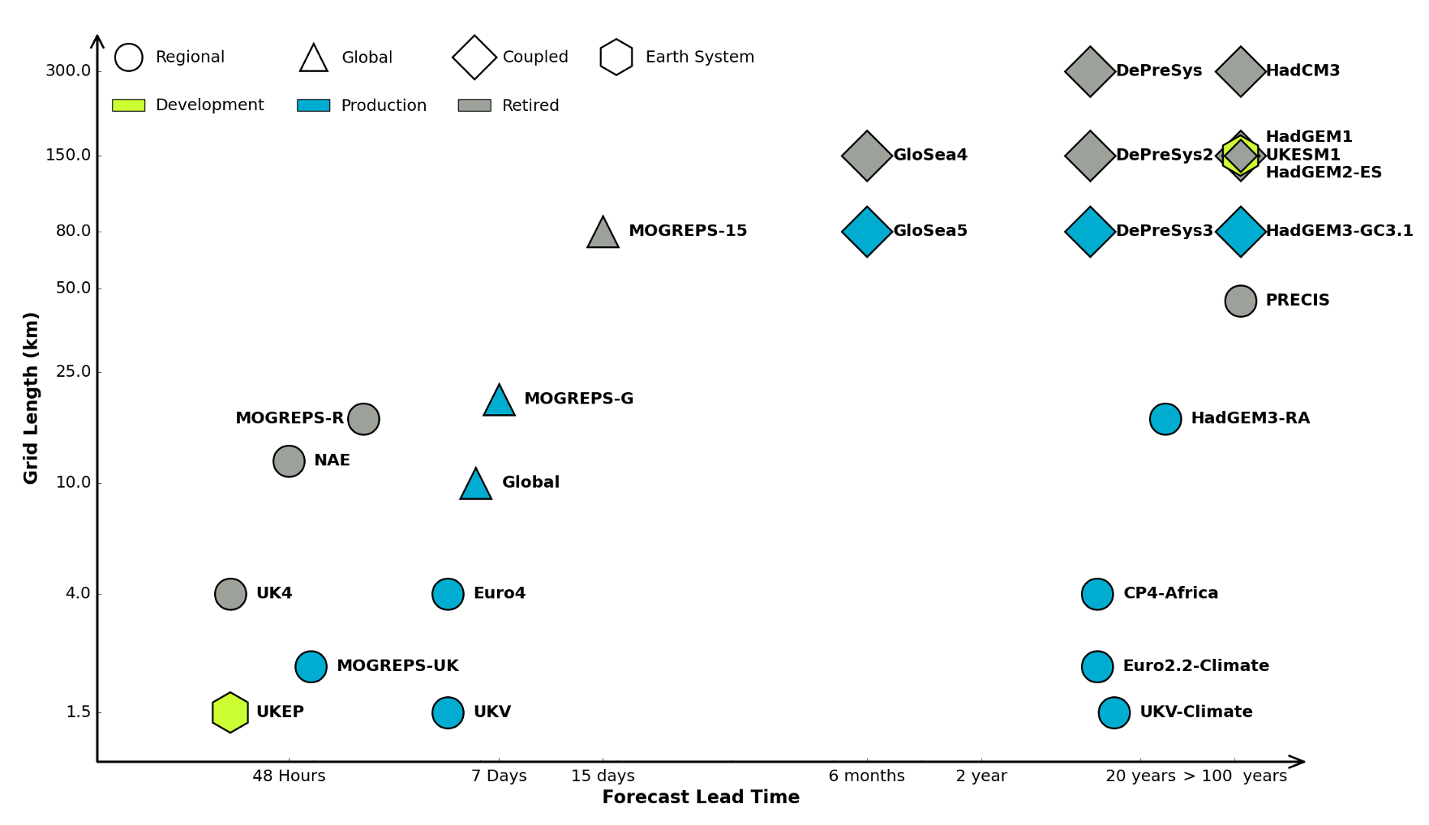

In this picture we can see the difference in application between a local weather forecasting code such as UK4 and all of the models in the bottom left part of this picture, and a global climate model (GCM) such as HADGEM3-RA in the top right of this picture,

* 1. How are the models tested?

A Global Climate Model (GCM) is a very complex piece of software with many millions of lines of code. Errors can arise in the way that the physics is represented, the algorithms used to solve that physics, the coding up of those algorithms, the data that is fed in to the calculation and the initial conditions used to start the whole system off. Because the climate models are based on weather models, one aspect of the testing is always available. Indeed, weather models are tested by comparing them against reality every six hours. A modern weather forecast updates its prediction constantly by comparing its predictions against data in a process called *data assimilation* [6]. Any systematic error in the code would quickly reveal itself in this process. A second check is that through mathematical arguments we can check the convergence of the algorithms used through the methods of *numerical analysis.* Thirdly, all modern climate algorithms assume that they are working with uncertain data. By using techniques from probability and statistics it is now possible to quantify this uncertainty so that we have a reasonable idea how accurate our forecasts may be. In particular we can build in uncertainty due to the model, the initial conditions and the ‘scenario’ (estimates of future human activity for example). A further way of testing a particular climate model is to compare it with the predictions of different models. There are many different climate centres worldwide. These use models which differ in the way they approximate the physics, the way they solve the resulting partial differential equations (for example by using a finite volume or a spectral method), and the various assumptions of human activity. Such centres include NCAR in the USA, the Hadley Centre in the UK, CSIRO in Australia, and CCSR in Japan. On the left we see the Hadley Centre predictions for the UK temperature with associated uncertainty, and on the right the predictions of global temperature using these various models (with the US predicting the lowest, the Japanese the highest and the UK in the middle).

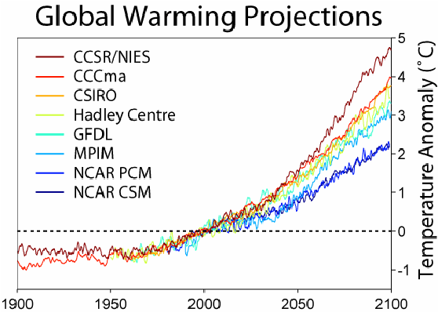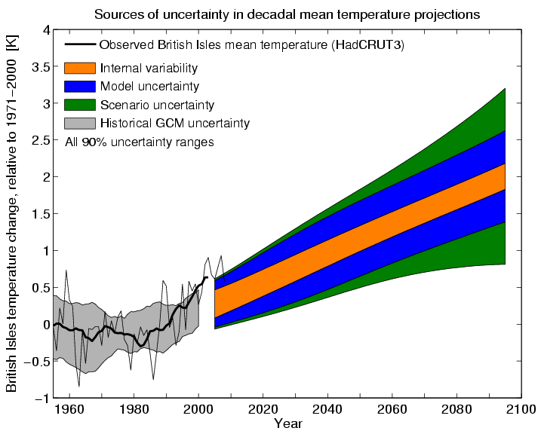

Unlike weather forecasts it is impossible to test a climate forecast directly against future data unless we are prepared to wait decades for the result. Instead we test them against past data using the hind casting method we looked at earlier. These are run over the 150 years for which we have reliable climate data and provide a careful check of all of the predictions of the model with what is observed. Essentially if a climate model can predict the past, then we have a good cause to believe that it can predict the future. As models for climate have now been around for long enough for certain climate variations to have taken place, we can also compare their predictions with variations of temperature and sea level rise observed over the last twenty or so years. Again the predictions have been good (and have been carefully monitored by the IPCC), although they have been faced with the very real problem of estimating how much Carbon Dioxide would actually be released into the atmosphere due to human activity. As with all human based issues, this is the hardest thing for any mathematical model to predict with any level of accuracy.

1. **Some ‘simple’ mathematical models of climate.**

There are several problems with using the GCM climate models preferred by the IPCC. The first is that their sheer size makes them very expensive to run, and the computers running them use a lot of energy in the process. For example the Met Office Cray XC40 supercomputer makes 14,000 trillion arithmetic operations per second, and uses 2.7 MegaWatts of power when it is running. It is indeed one of the ironies of modern climate science, that the computers doing the calculations contribute, by doing them, to global warming. They also take a long time to run, so that it can take days to get a forecast of the climate in 100 years. To get an estimate of the climate in a million years is quite impossible with a GCM. Thirdly, it is hard to do ‘what if’ experiments, in which we look at the effect of changing different parts of the model (such as the amount of greenhouse gases). Finally (and crucially for someone like me) the models are much to complex to be analysed by hand, so whilst we may be able to predict things, it is very hard to explain why we are seeing what we see. To address this we work with a hierarchy of different models of increasing complexity. At the simplest level are energy balance models (EBMs), next level up are Box Models which divide the Earth up into a number of large boxes, next come Earth Intermediate Complexity models (EMICS) or Reduced Climate Models (RCMs), then there are the (atmosphere and ocean) GCMs described above, these in turn are part of very complex Earth System Models (ESMs).

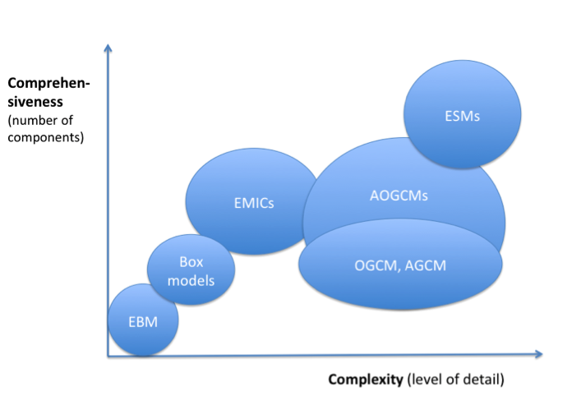

* 1. **Energy balance models (EBMs)**

The simplest of all of these models (and yet still with a good degree of predictability) are Energy Balance Models (EBMs). Whilst this model is really simple (indeed it can be implemented in ExCel) it can be used to inform us in the implementation of the 2016 Paris Agreement to keep the Earth’s temperature to below 1.5 Degrees Centigrade, and even to find the mean temperature of the Moon.

We construct an EBM using the steps outlined in Chapter 1.

**Step 1** is to observe that that all of the energy coming to the Earth from the Sun must either be radiated back into space or used to heat up the Earth and its atmosphere. Balancing these two (as energy must be conserved) gives us the basis of a simple climate model.

In **Step 2** we consider the basic physical laws. The whole Earth is being heated up by the Sun and releasing its energy back into space. We take S(t) to be the radiation from the Sun, which at any one time illuminates one half of the Earth’s surface. This illumination is primarily seen as short wavelength radiation. A proportion of this radiation is reflected back by the Earth, where a is the Albedo. If a = 1 then all of the radiation is reflected, and if a = 0 then none of it is. So the total radiation reaching the Earth’s surface is (1-a) times the average solar radiation. This radiation heats up the Earth and its atmosphere, which in turn re-radiate it back into space as long wavelength radiation (infra-red). The amount of this radiation is given by the black body radiation law, in which the radiation is proportional to the fourth power of the absolute Temperature. Not all of the radiation from the Earth goes back into space. Indeed a significant proportion of it is absorbed in the atmosphere and reflected back to Earth. This absorption is the result of the Green House gases in the atmosphere, such as Carbon Dioxide, Methane and water vapour.

For **Step 3** we look at how to simplify this system. A major simplification is that we can model these processes by making the approximation that the Earth has an average temperature of TE and that the atmosphere has an average temperature of TA. (This is of course a huge simplification, as it ignores the change in the temperature from one part of the Earth to another. However it is still useful, and gives a good estimate for TE.)

For **Steps 4** and **5** we now formulate these processes as equations, and solve the equations.

We start by looking at the radiation S(t) coming from the Sun. If the Earth has radius R then its surface area is 4π R2. The area of the disc that the Sun illuminates is in contrast π R2 and the flux of the solar radiation is π R2 S(t). The *average* Solar radiation on the Earth’s surface is then π R2 S(t)/ 4π R2 = S(t)/4. This value can be measured and is 342 W/m2 .

The amount of short wave Solar radiation which is not reflected back into space passes through the atmosphere. The amount of this which reaches the Earth, warming it up is given by

τSW (1-a) S(t)/4

where τSW is the short wave transparency of the atmosphere. The atmosphere is mostly transparent to short wave radiation and we have τSW = 0.9. The remainder of the Suns energy

(1-τSW)(1-a) S(t)/4

helps to heat up the atmosphere.

The Earth heats up to a temperature TE and radiates an energy flux FE . This can be calculated by using the black body radiation equation and we have





where is the *Stefan-Boltzmann constant*.

This flux is in long wave infra-red radiation. As it passes through the atmosphere most of it is absorbed and this also helps to heat the atmosphere up. Now we introduce another factor τLW which is the *transparency of the atmosphere to long-wave radiation* in the infra red. Most of the infra red radiation is absorbed due in part to the action of the greenhouse gases. As a result τLW =0.2 which is a lot smaller than the short wave transparency. (In other words the atmosphere lets light in but is reluctant to let heat out.) The amount of the Earth’s radiation which goes into space is then τLW FE. The remainder of the radiation from the Earth is (1-τLW)FE which also helps to heat up the atmosphere. When this is combined with the energy (1-τSW)(1-a) S(t)/4 from the Sun, it raises the temperature of the atmosphere to a temperature TA. The atmosphere itself then radiates energy, part of which is radiated into space and the other back to Earth. The energy flux from the atmosphere divides into FA towards the Earth and FA into space. The value of FA is also given by the black body formula



As this radiant energy is also in the infra red, a proportion τLW FA reaches the Earth’s surface and helps to heat it ap.

Now we can do some balancing of the energy fluxes. On the Earth’s surface we have a balance of the incoming long wave heating from the atmosphere and short wave heating from the Sun, with the energy flux from the Earth so that

FE = τSW (1-a) S(t)/4 + τLW FA.

Above the atmosphere there is a balance between the energy coming in from the Sun and the energy leaving from the Earth and from the atmosphere gives:

τLW FE + τLW FA = (1-a) S(t)/4.

Adding these two energy balance equations together, cancelling the term τLW FA, which appears on both sides of the formula, and rearranging we have



It is convenient to set



Here e is the *emissivity of the atmosphere* which is *proportion of the radiated energy from the Earth which goes back into space.* The value of e is 1 when there is no atmosphere, such as on the Moon, and is currently measured to be about 0.605 on the Earth. (This is slightly different from the value given above formula due to some other energy transfer mechanisms which I have not included in the above model, such as evaporation and thermal convection.) It then follows that



Rearranging this formula allows us to calculate TE from the equation:



We call this the *energy budget equation,* and it is the main prediction from our model.

For **Step 6** we make a check of the energy budget equation against some data. The current mean amount of solar heating on the Earth (allowing for variations in time and space) is



Similarly, the current accepted values of the constants on the Earth are a = 0.31 and e = 0.605. Substituting these values, together with the above value of the Stefan-Boltzmann constant gives a mean absolute temperature of the Earth of

TE = 288 K

which is about right.

As a separate test, on the Moon we have e = 1 as it has virtually no atmosphere (due to its reduced gravity). For the same values of the other constants we can predict a mean temperature of 254K. This is again about right, although, due to its slow rotation, the temperature of the Moon is very different on the side which faces the Sun from that which is in darkness.

**Step 7** asks us to consider improvements to this simple model. This takes us deeper into the subject of climate modelling, and we will do this shortly. However, the Energy Balance Model whilst simple, is robust enough to allow us to make some predictions.

**Step 8** Indeed, having made the checks, we can use the energy budget formula to predict possible future climate change and to influence policy makers.

Key to these predictions is the transparency of the atmosphere to long wave radiation τLW . The lower the value of the transparency τLW the more that infra red radiation is absorbed. In particular as τLW decreases then so does the emissivity e. If follows directly from the energy budget formula that if the emissivity e *decreases* then the mean temperature of the Earth TE *increases*. It is this prediction which gives us a direct link between Carbon Dioxide levels and the Earth’s temperature. It is a scientific fact that the long wave transparency of the atmosphere depends directly on the composition of the *greenhouse gases* in it. (These gases are called greenhouse gases because they act rather like the glass in a greenhouse to reflect heat back to the Earth.) Carbon Dioxide is one of these and the level of Carbon Dioxide contributes to the emissivity (alongside that due to the other greenhouse gases of water and Methane). The more Carbon Dioxide there is in the atmosphere, the lower its transparency to long wave radiation, and hence its emissivity. A table of the calculated emissivity due to Carbon Dioxide alone is given below. The conclusions from this table are unambiguous. As the level of Carbon Dioxide *increases* so the emissivity *decreases*. Hence the temperature TE increases*.* *Thus the huge increases in the levels of Carbon Dioxide in recent years are, according to this model, a clear contribution to global warming*. This we can tell all policy makers.



It is worth saying that similar predictions on the increase in the mean temperature of the Earth can be made when there is an increase in Methane levels. These increase both due to modern agriculture (in particular farm animals) and the melting of the Arctic permafrost. (Whilst water moisture is also a greenhouse gas, it is less important to temperature change as it frequently leaves the atmosphere as rain, whereas Carbon Dioxide and Methane stay in the atmosphere for a long time).

Using the model we can start to consider the issues related to the Paris Agreement and its impact on policy makers. In particular a value of 1.5K has been agreed by the Paris Agreement and felt to be the maximum sustainable value of the Earth’s temperature rise over the next 1oo years.

The **Equilibrium Climate Sensitivity (ECS)** is the global mean surface warming which follows after a doubling of the current levels atmospheric Carbon Dioxide. If W = S(1-a)/4 is the total amount of energy reaching the Earth, then it follows from the energy budget formula that



If we use the above values for e and σ and set TE = 288K, then



It is estimated that doubling atmospheric Carbon Dioxide has the effect of changing W by about 4W per metre squared. From the above this would indicate a rise in temperature of 1.23K. This is below 1.5K. This might lead to grounds for optimism that we can sustain a doubling of the amount of Carbon Dioxide in the Earth’s atmosphere and still stay safe. However the climate is more sensitive than this simple model implies because there are other feedback mechanisms in the climate we have not considered in the simple model. A significant one of these is the effects of ice melting, which we will look at presently

* 1. **Other climate models and the prediction of the ice ages.**

As we said above, Step 7 is a window into a vast range of other (reduced) climate models. All of these make many simplifying assumptions depending upon the amount of detail that they need to predict and the time-scale over which they have to be applied. Mathematical models exist, for example which make a fair prediction of the roughly four yearly El-Nino warming of the Southern Pacific Ocean. Similarly there are mathematical models which aim to predict what will happen to the currents in the Atlantic Ocean if the Arctic ice all melts.

One of the most intriguing questions in climate change is what causes the ice ages. As we have seen the ice ages occur roughly once every 100,000 years and predicting them is important in helping us to understand what the climate will do in the next 1000 years. Roughly what has happened in the ‘recent’ series of six ice ages is that the Earth has cooled down over a period of around 100 000 years, during which it has had extensive glaciation (the glacial period). It then suddenly warms up in a few thousand years (the inter glacial period). It then cools down and the cycle repeats. Despite many years of trying we are still very far from understanding what causes the ice ages and why they have such a regular period. A popular theory [7] is that they are simply caused by wobbles in the Earth’s audience (so called Milankovitch cycles). However, this theory neither predicts the period correctly or explains why about 750,000 years ago the frequency of the ice ages changed from 40,000 years to 100,000 years, in the so called Mid Pleistocene Transition (MPT). Predicting the ice ages over such a long period is well beyond the capabilities of a GCM and hence they must be studied using a simpler model such as a box model. Indeed, predicting the ice ages requires a model which is more sophisticated than an energy balance model and less sophisticated than a GCM, but which. Doing this illustrates one of the main hazards of climate modelling. There are many possible simplifications of the full climate model, and there is far from a consensus as to which one should be used to predict the ice ages. In my own research I have counted over 30 so far. See [8] for more details. A model that I am currently studying, together with my team of PhD students, was proposed in 2004 by Paillard and Parrennin [?] and looks at the close coupling of temperature, atmospheric Carbon Dioxide and overall ice levels. This model assumes that the Earth is heated quasi periodically by the Sun due to the Milankovitch cycles. During a glacial period the glaciers slowly advance and the Earth cools down. At the same time the atmosphere cools and cannot retain its Carbon Dioxide and this is stored deep down in the oceans. However the oceans can only store a certain amount of Carbon Dioxide and it is released when it gets to a critical value and the oceans lose the ability to store it any more. When the Carbon Dioxide is released from the oceans into the atmosphere there is a sudden warming up of the Earth due to the green house effect that we looked at in the last section. When all of the Carbon Dioxide has been released the Earth enters another glacial cycle. This model both predicts the right period of the ice ages and possibility of the MPT so I am hopeful that we are along the right lines. Below is the prediction of a measure F of the climate state as a function of time (in thousands of yeas) which is given by this model in [??]. You can compare this prediction to the ice age temperature and ice cover values shown in Section 2.2.

1. **Common criticisms of climate models**

I do a lot of work on climate models and give many talks about them to many different audiences. This leads to a vibrant correspondence in which I see many questions raised about climate models and their applications and predictions of rapid change due the actions of humanity. Common amongst these are the following:

1. Surely the most important effect on the climate is the Sun and you have missed this out of your models
2. The climate has always been changing. What we are seeing now is just what you would expect from natural variation.
3. Chaos theory tells us that we can’t predict anything that far into the future.
4. Carbon Dioxide rise always comes after temperature rise.
5. Climate models leave out important factors such as volcanic action.
6. Climate models never make accurate predictions.
7. Unprintable, ad hominen attacks on climate scientists, who are (apparently) only in it for the money or for political reasons.

In answer to these:

1. The variations in the radiation from the Sun are certainly included in climate models (you can see their effect in the term S(t) in the energy budget equation), and these variations have a significant effect over the long term (for example they were one of the main causes of the little ice age). At the moment the Sun is slowly decreasing in its output so if the Sun was the main reason for climate change then we should be seeing the Earth cooling down, rather than warming up.

2. Yes the climate does change naturally but (as we have seen) on a much longer timescale than we have been seeing in recent years. Natural variations (due for example to the Milankovitch cycles or variations in the output of the Sun) occur over time periods of the order of thousands of years or longer. The rapid changes in temperature that we have been seeing recently have occurred over at most tens of years. This is far too fast to be due to natural variation, and must instead be due to human activity.

3. This is exactly what we looked at in Chapter 2. It is the average properties of climate that are important, and models with chaotic solutions have very predictable average behaviour.

4. In the past Carbon Dioxide and temperature values have very closely coupled, so a rise in one leads to a rise in the other, which leads a rise in the first, etc. However, what we are currently seeing is a very rapid rise in Carbon Dioxide levels, and the energy balance model clearly shows that this is a direct cause of temperature rising.

5. Whilst it is of course difficult to predict exactly when the next volcano will erupt, it is possible to make a statistical estimate of the level of volcanic both n the past and in the future. This then can be, and is, incorporated into the climate models.

6. Climate models DO make predictions which can be tested, and they are validated in part by a process of such careful testing. The hind-casting test that we looked at earlier is just such an example. In fact the IPCC reports are full of examples of the predictions of climate models compared with actual measured data. Even quite simple climate models have made accurate predictions of the current rise in temperature and sea level.

7. Sadly the *majority* of the comments fall into this category. These are best ignored. You have to develop a thick skin when you work in climate science!

1. **Are we past the point of no return?**

In Chapter 2 on Chaos Theory we touched on the theory of tipping points where small changes of the parameters in a model lead to irreversible change in the system. One of the key questions about climate change is whether it is too late to change things, or whether we might be past a point of no return, so that no matter what we do the climate will change regardless.

An example of where this might happen we go back to look at the Energy Balance Model described above and (as we usually do in **Step 7** of the modelling process) we add in additional physics to the earlier climate model. In particular the energy balance model can be improved to account for what is called the *ice-albedo effect*. The albedo a, that we considered as a constant above, in fact depends indirectly upon the average temperature of the Earth. In particular, it depends on the *total amount of ice covering the Earth*. The more ice there is the more reflective the Earth’s surface and therefore the higher the value of a. Similarly, a decreases as the amount of ice decreases. The amount of ice in turn depends upon the mean Earth temperature, which from now on we will just call T. The higher the temperature the less ice there is, and the lower the temperature the more ice. Thus the albedo a decreases as the temperature T increases. As a result the sea gets darker and does not reflect the light from the Sun so well when T increases. As a consequence of this more of the Sun’s energy gets to the Earth’s surface, and the Earth gets warmer still. In principle this positive feedback cycle could continue until of the ice has melted. This is a process of rapid change that would be hard to stop once it has started. This phenomenon is precisely what would be expected at a tipping point*.*

Is there mathematical evidence for this? It is actually quite hard to model the process of linking temperature to albedo, as we have to take into account the rise and fall of sea ice and also the advance and retreat of glaciers over the Greenland and Antarctic ice sheets, and these introduce delay and uncertainty into the system. If the Earth was covered with ice its albedo would be a=0.84, and if there was no ice then a = 0.14. However, one plausible and simple model is that a(T) is a direct function of the Temperature. If the temperature is very cold then the Earth is entirely covered by ice and its albedo is just that of the ice, which is about a=0.7. Conversely, if the temperature is very hot, then the albedo is lower and is a mixture of the albedo of the ocean and the land, which is approximately a=0.2. Between these two the albedo varies smoothly. An example of a function a(T) which has this property is given by the formula



(where T is measured in degrees Kelvin) and has the form:



The effect of the temperature on the albedo of the Earth is two fold.

As a **first** observation this dependence of the albedo upon temperature makes the whole Earth/atmosphere system *much more sensitive to change*. In particular *it increases the sensitivity of T to changes in the emmisivity e*  given by dT/de. As this is in turn linked to Carbon Dioxide levels it means that the change in the temperature due to changes in Carbon Dioxide is amplified. Without the ice-albedo feedback a simple calculation gives



As this is negative, this means (as we have already shown) that as e decreases, then T increases.

If the ice-albedo feedback is included, this sensitivity changes to



Now, as T *increases*, so the albedo a *decreases.* Hence da/dT < 0. this means that the absolute value of dT/de in this case is *larger* than the value calculated above when we did not consider the albedo changes. As a consequence the temperature T increases rather more rapidly for a given amount of Carbon Dioxide added to the atmosphere than it would if there was no change to the albedo of the Earth. This means that our earlier optimistic estimate for the effect of changing the Carbon Dioxide on temperature is simply mistaken.

A **second** interesting effect is that in this model the Earth can now exist in a number of different climatic states. For example, if we take the current value of e = 0.61, then the energy balance equation has *three different (steady state) solutions* given by T = 288K (our current temperature), T = 279.6K and T = 232K. Of these the first is stable (a warm Earth) as is the third (a cold Earth) and the other value represents an unstable middle state. The multiple states as a function of e are illustrated below in an S-shaped figure. In this figure the top branch is the stable warm Earth (the current state) and the bottom branch a stable cold Earth.



This picture shows the existence of two *tipping points* when the climate can change rapidly at e = 0.38 and e = 0.63. If we were in a cold Earth situation (often called an *ice ball Earth*) and e dropped below 0.38 then we would see a rapid warming of the Earth, similarly if we were in a warm Earth scenario then increasing e above 0.63 would lead to very rapid cooling. It would seem from this model that the current state of the climate is not close to such a tipping point, so we are not past the point of no return (at least in this model). However, the ice-albedo effect certainly makes the whole system much more sensitive to the effects of increased Carbon Dioxide emissions.

There are other aspects of the Earth’s climate, however, which might lead to a tipping point in its behaviour. These are well described in [9]. One of the most commonly quoted of these is the melting of the Siberian permafrost which will lead to the release of the Greenhouse gas Methane, which will make the Earth warmer, leading to more melting. Other potential tipping points are the change on the Atlantic circulation and the loss of the rainforest. Examples of such tipping points due to Lenton [9] are given below.

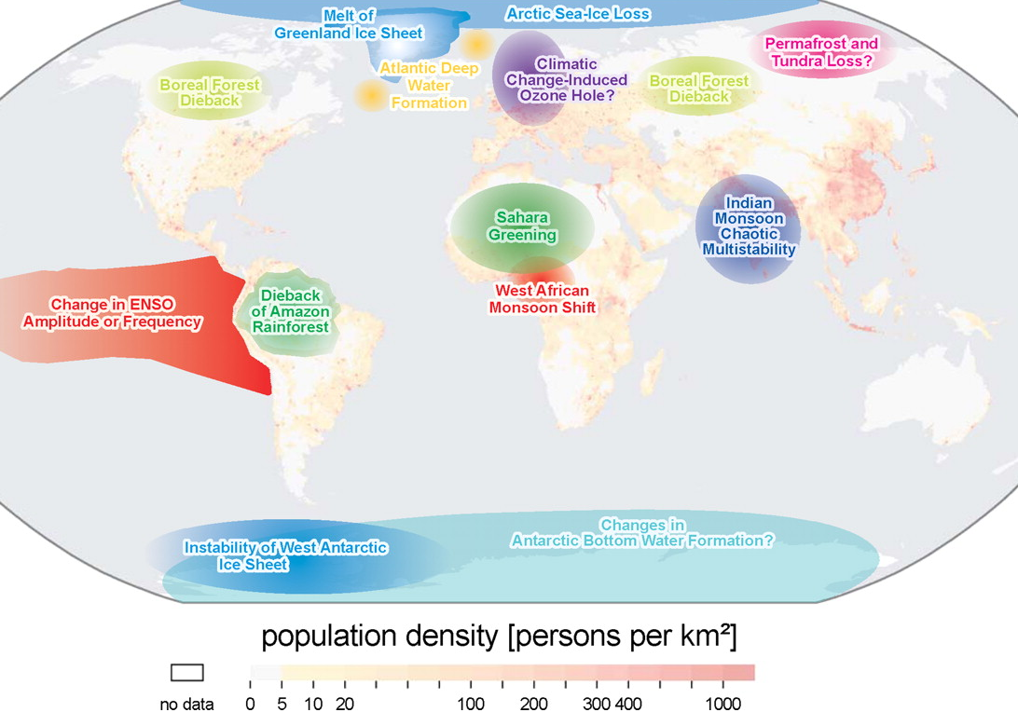

It is worth saying however that the theory behind the role of tipping points in the climate is still unclear, as is their detection. However they are certainly worth monitoring and this is an area of active research.

1. **Some predictions of the future**

So, are we all doomed? It is not my job as a mathematician to say this one way or the other. However, I can urge everyone to be mindful of the effects of climate change. Despite what certain politicians may say, the evidence for human made climate change is very strong. This is supported by mathematical models which imply that unless we do act now the Earth’s temperature will continue to rise, and we can make clear predictions about how much that rise will be given the amount of Carbon Dioxide that we are releasing into the atmosphere. How we mitigate that rise, for example by using Carbon Capture Technology, or the use of renewable energy, is the subject of another lecture. But perhaps the main contribution that maths can make is, by using data and careful models, to take the hot air out of the climate debate. If you want to read more on this I strongly recommend the (free) book [10].

**References**

[1] The most recent IPCC report is given in <http://www.ipcc.ch/report/sr15/>

[2] The 2016 Paris Agreement is described in <https://en.wikipedia.org/wiki/Paris_Agreement>

[3] HRH The Prince of Wales, T. Juniper and E. Shuckburgh, (2017), *Climate Change*, Ladybird Books Ltd., London.

[4] The 5th IPCC assessment report is given in <http://www.ipcc.ch/report/ar5/>

[5] The website <http://wxcharts.eu> gives an excellent set of easy to follow, and up to date, weather charts.

[6] C. Budd, M. Cullen and C. Piccolo, (2016), ‘*Improving Weather Forecasting Accuracy by Using r-Adaptive Methods Coupled to Data Assimilation Algorithms,* in UK Success stories in Industrial Mathematics, Springer

[7] J. Imbrie and K. P. Imbrie, (1979). Ice ages: solving the mystery, Short Hills NJ: Enslow.

[8] H. Kaper and H. Engler, (2013), *Mathematics and climate*, SIAM

[9] T. Lenton, (2016), *Earth system science: a very short introduction*, Oxford

[10] D. Mackay (2015), *Sustainable energy without the hot air*, https://www.withouthotair.com/download.html